18 September 2024 postcard

A leisurely travel day today.

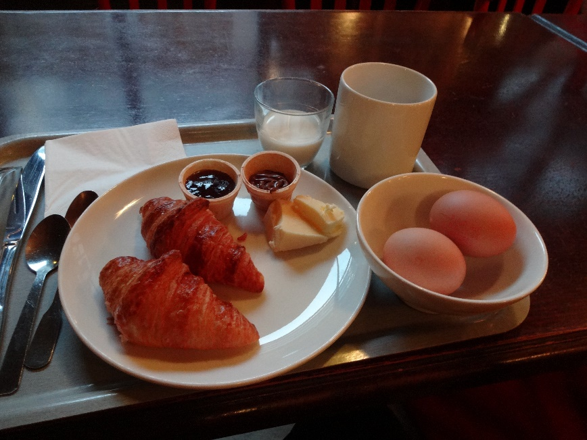Our flight, originally at 1:50 pm from Charles de Gaulle airport was rescheduled for 3:20 pm, so we had the luxury of packing in the morning rather than after reeling home from Chez Papa stuffed to the gills with cassoulet.

I enjoyed one last boiled-egg breakfast, this one with a couple of mini croissants, butter, and a little cup each of Nutella and strawberry jam.

We met in the lobby at 11 am, checked out of the hotel, alerted them to a slow leak in my bathroom's sink faucet, and had them call us a cab, which arrived in 3 minutes.

We made rather slow progress out of the city, enabling me to get these shots of the gates of the historic Gambetta cemetery and of the beginning, right next to it, of an amazing line of black marble plaques engraved (in quite small letters) with columns and columns of the names of Parisians who died in WWI. It continues along the outside wall of the cemetery for half a mile.

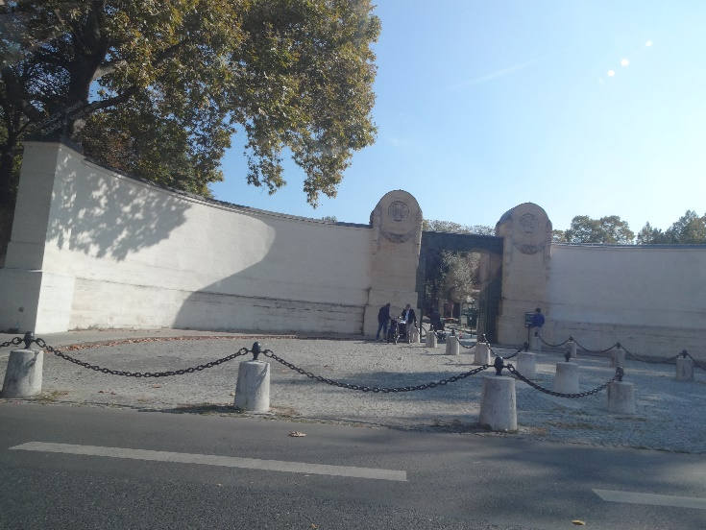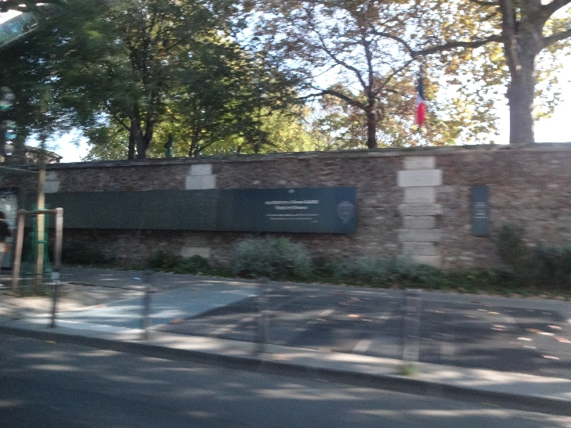

Once we got outside central Paris, we moved right along at freeway speed, except for one section of bottleneck. Still, we reached the airport before noon.

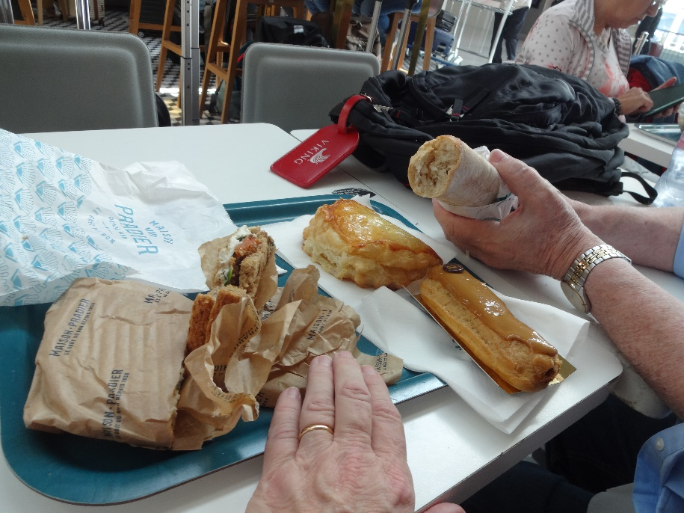

Unfortunately, CDG won't let you check your bags or go through security until two hours before your flight, so we went to Maison Pradier, outside security on terminal 2F, for an agreeable lunch of a ham and Comté cheese baguette, a toasted sandwich of smoked salmon, fresh spinach, and cream cheese on malted bread, an apple turnover, and a coffee éclair (which Pradier calls a coffee "coup de foudre," a thunderstrike; "éclair" is French for "lightning," you see).

In Milan, we were met, as promised, by a driver who took us to the Tauck hotel, where we were the last to arrive, because of our late flight. But we changed and brushed up in time to join the group for the end of cocktails and our welcome dinner at the hotel.

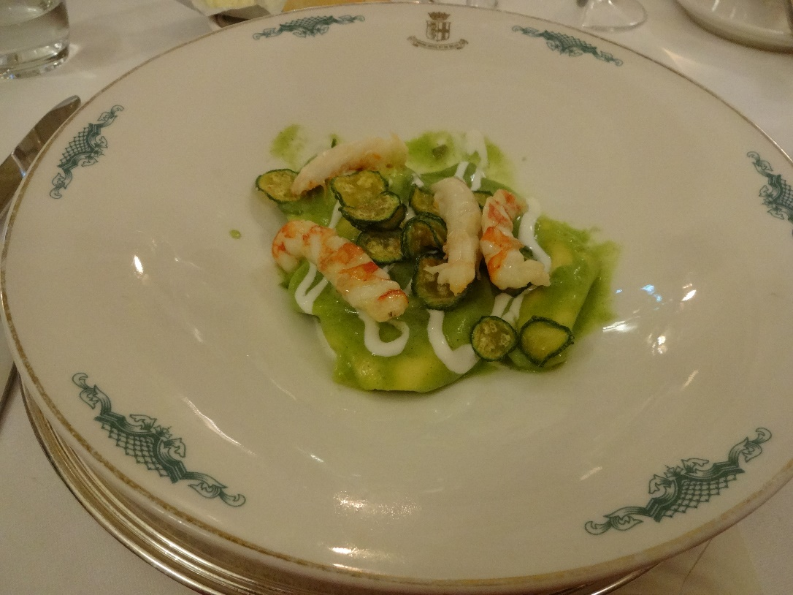For our first course, David and I both chose these tasty ravioli of prawns and stracciatella cheese in a zucchini sauce. Excellent!